Lotus Educational Fund Ltd
Report to Donors 2014 – June 2015

Australians enabling access to education for Lao ethnic girls.

ABN 76 130 576 199

Established 2008

VISION
The Lotus fund aims to provide educational opportunities in rural Laos for ethnic girls living in poverty in isolated villages by assisting them to improve their life opportunities through regular attendance at school.

MISSION STATEMENT
To empower the lives of girls and young women who are vulnerable to domestic trafficking through educational opportunities. Through literacy it is hoped that the economic well being of the girls will be improved and their individual lives will be changed in ways that will allow them to contribute to the advancement of their local communities in powerful ways.

ADVOCATE
The Lotus Educational Fund Ltd acts as a voice to raise awareness publicly. The Fund operates to ensure the commitment of the wider community to the education of girls living in poverty in Lao PDR.

A wonderful 2014-2015 in Summary:

St Therese’s Art Show and donation – Students in Stage 3 held an exhibition that highlighted for students the work of the Lotus Foundation. St Therese’s has been supporting the Lotus Educational fund for many years. Their kindness and generosity is highly valued and appreciated. Funds are used to purchase education supplies, pay school fees and help improve education standards.

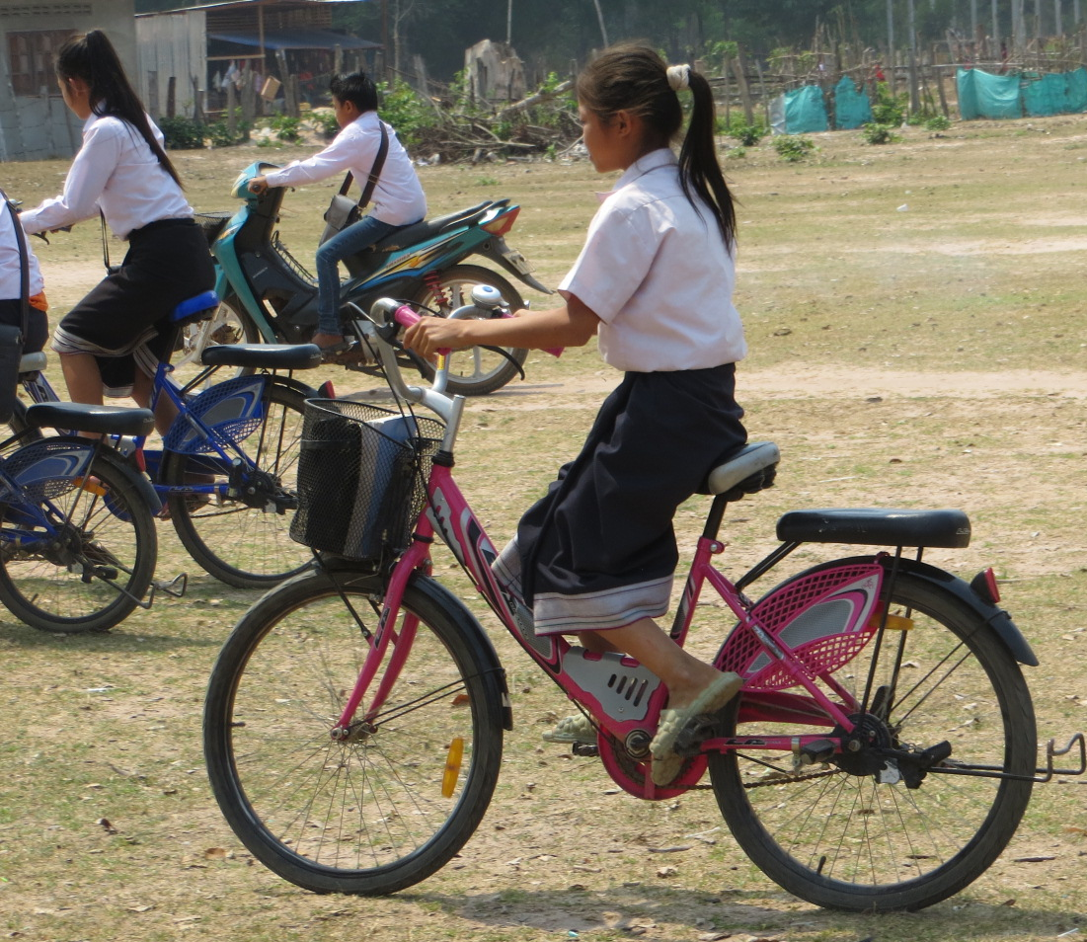
Saiphone on her bicycle that was donated by the student’s at St Therese’s a few years ago. Saiphone rides her bike each day to school instead of walking the long distance.

Literacy Boxes and Reading Lamps – The 40 Grade 2 girls were each provided with a solar lamp, a book and a cloth bag for storage.

Charity Bike Ride – Helen Keogh rode her bicycle from Perth to Sydney to raise funds for the Lotus girls. Starting on August 10th 2014 and finishing 63 days later after covering 4800km with just one flat tyre.
Helen on Day 1 in Perth, Western Australia. From coast to coast across Australia.

Logistical Support Officer – Ms Da continued in this important, in country, role successfully coordinating with VTE seamstress, purchasing all educational supplies, labeling each pack, boxing of good and delivering boxes to MMG for transportation of goods to SVK in a timely manner.

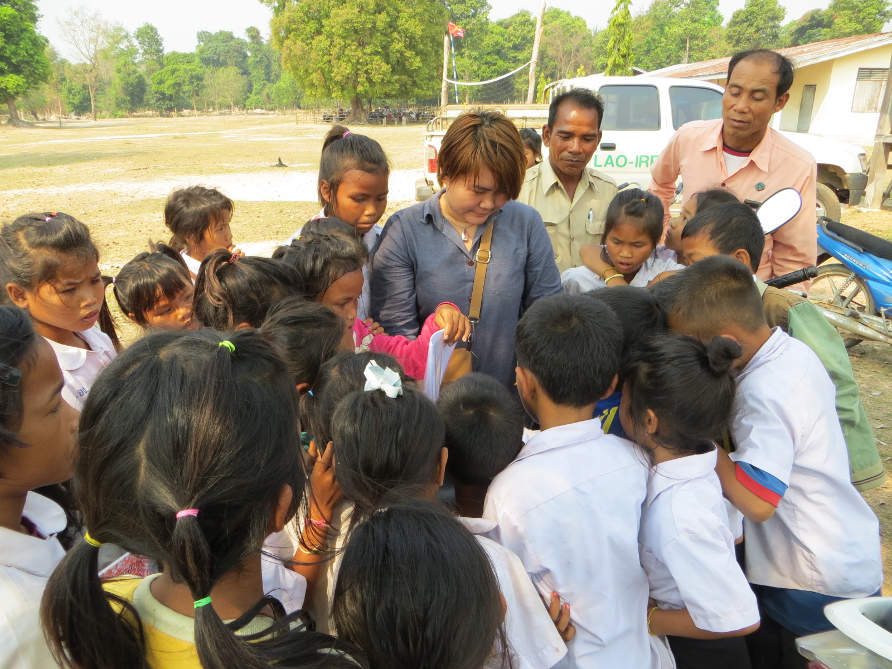
Ms Da, the Logistical Support officer, on the 5th March 2015, checking student names and photographs at Nong Kalong Primary School.

Website – Helen received pro bono training on website building and made a start on updating and improving the Lotus website.

Lotus Book – printed a couple of copies as a test print.

Feb 22nd 2015 School visit – Dianne Gamage and supporters collect video footage and photographs to create the video Saiphone’s Story. This video is available on the Lotus webpage. http://lotuseducationalfund.com/
The Lotus Story: Saiphone.

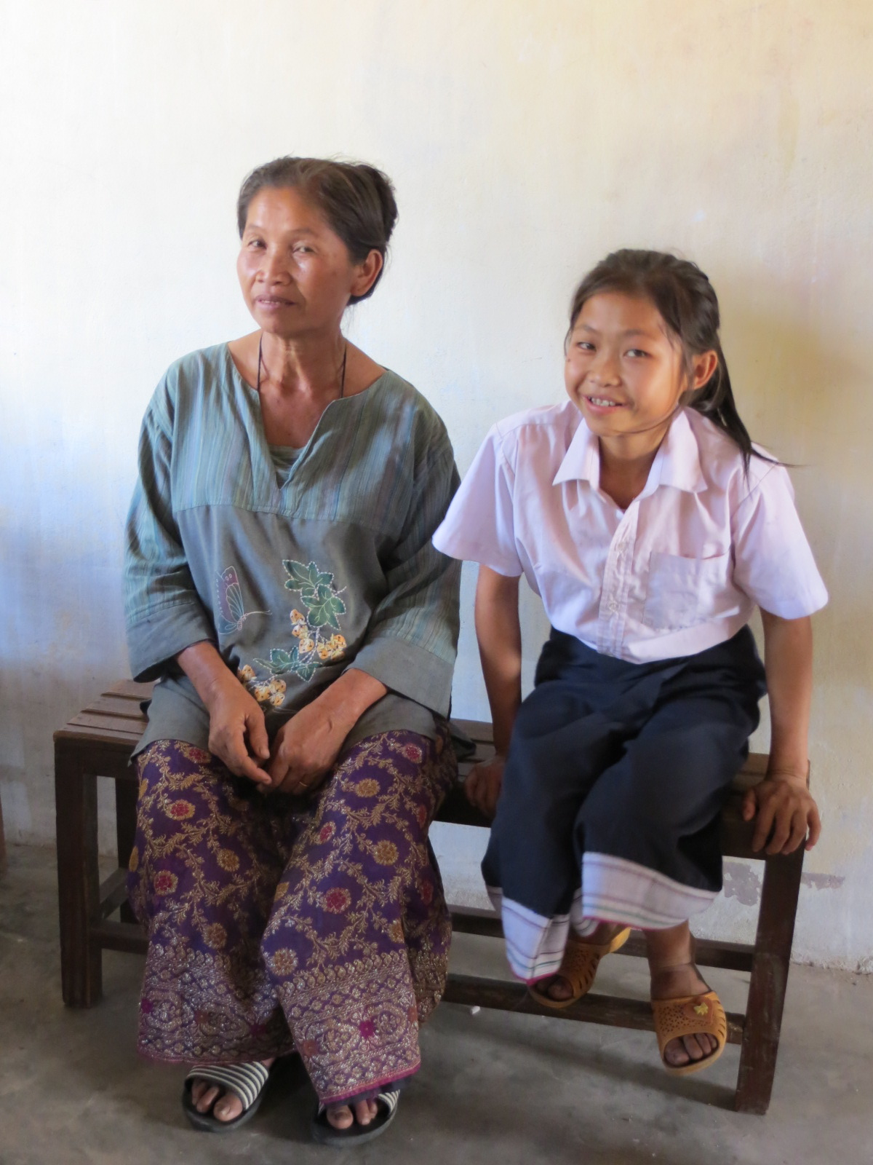
Saiphone and her mother during the making of the video in February 23rd 2015. Picture taken at Nong Kalong School.
Saiphone talks about the benefits of going to school and being grateful to Lotus for supporting her.
Saiphone is now in Year 7, the second year of Secondary school.
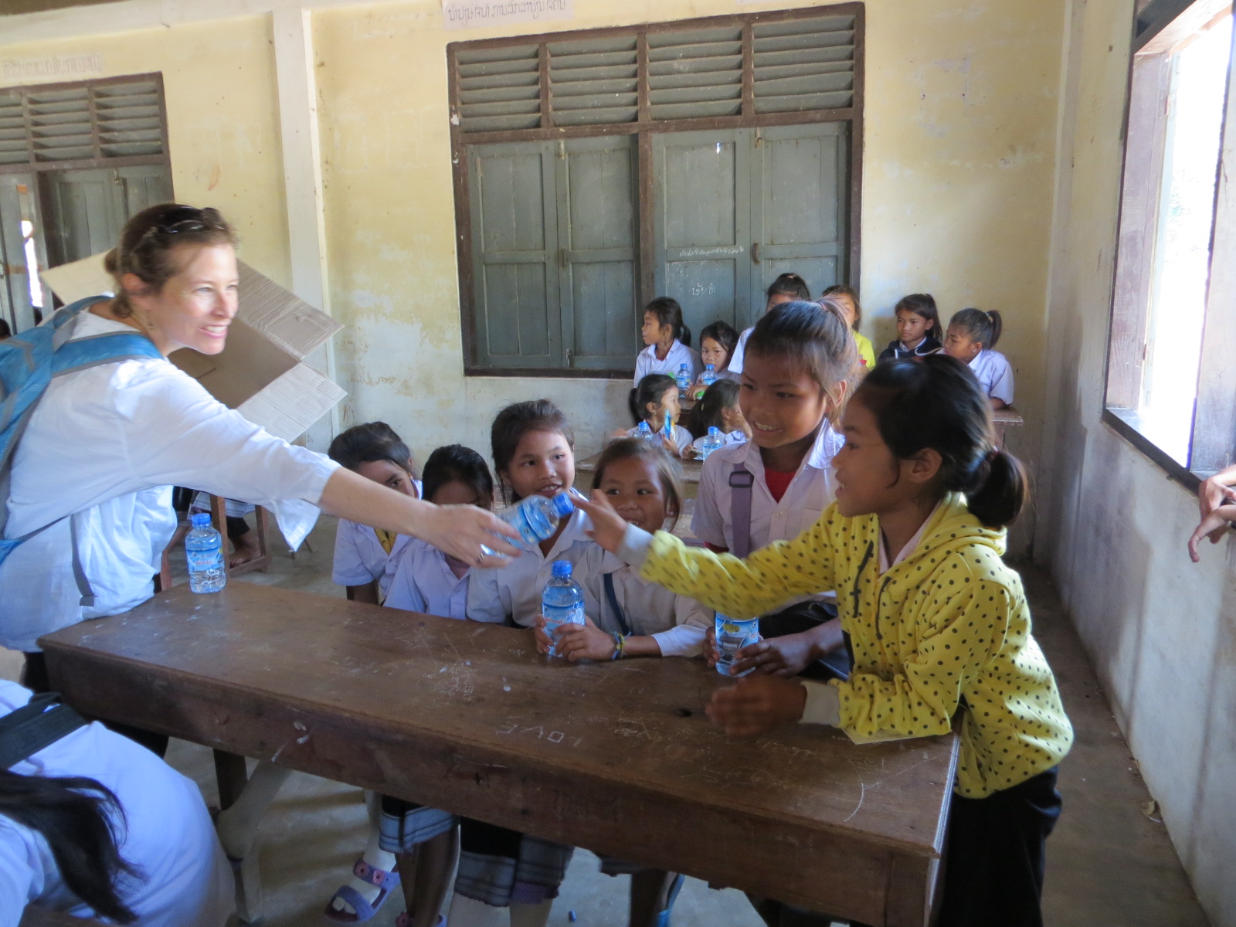
February 2015 school visit. Jessica passing bottled drinking water to the Lotus girls, Year 2 at Nong Kalong School.

May 2015 School visit – A highly successful visit to Nong Kalong school to meet all 78 girls and their parents. Distribution of the educational supplies to be used in Sept 2015. Measuring each girl for her new uniform.
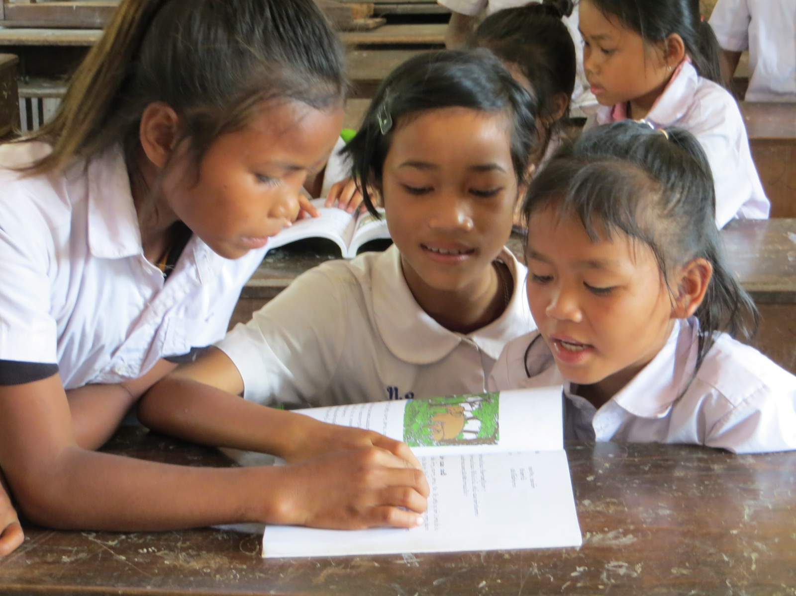

May 2015 – School fees for the coming academic year Sept 2015 – June 2016 was not paid to the Principals during the school visit. This money will be paid in October / November 2015 when Helen visits the schools and checks that each girl in the program has returned after the long summer break.

Photographic file – Each of the 78 girls now has a photograph on file with her Lao name and English phonetic translation. This document is used when visiting the schools to ensure the 78 girls are in attendance, to help to get to know each girl by name and to track any school absences.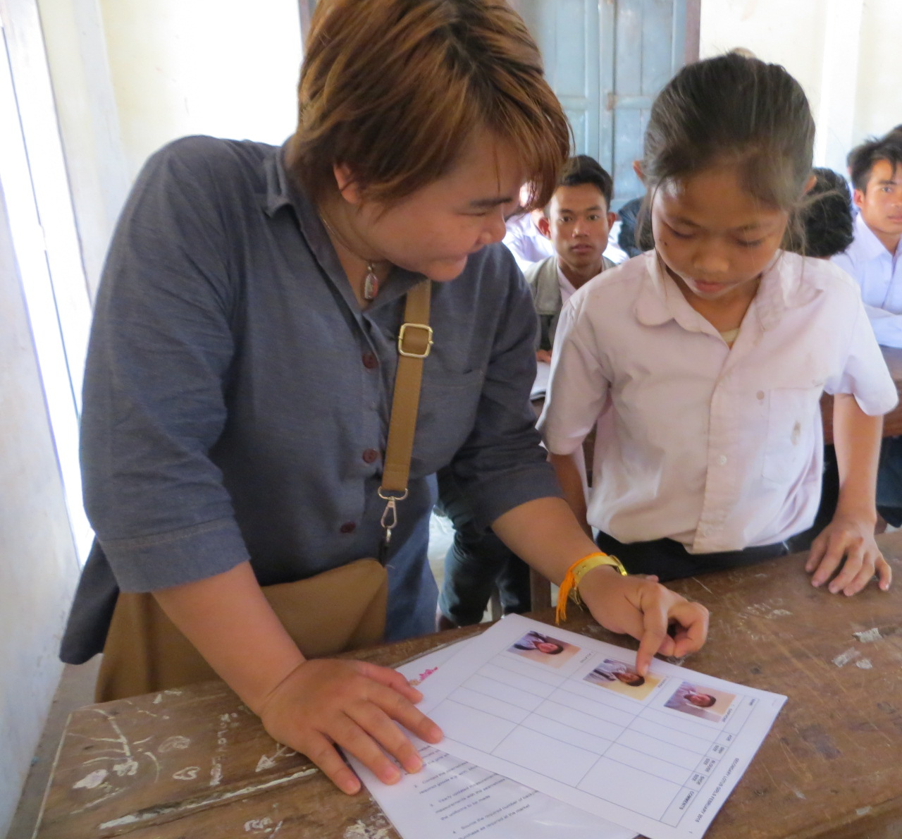
Ms Da using the photographic record to accurately record and identify each of the 78 Lotus girls.
Conference Presentation – Dianne Gamage, founding member of Lotus Educational Fund presented in Kota Kinabalu, Malaysia in March 2015 at the EARCOS conference. Dianne’s presentation was focused on ‘Bridging Barriers Through Intercultural Understanding’. Her next presentation will be in Feb 2016, in Bangkok at the AIE World Conference –‘Engaging with Difference: Finding Ways Forward’.

Donation of transport from MMG – Many large boxes are freighted each year by MMG from Vientiane to Savannakhet. We Thank MMG for their ongoing support, greatly appreciated.

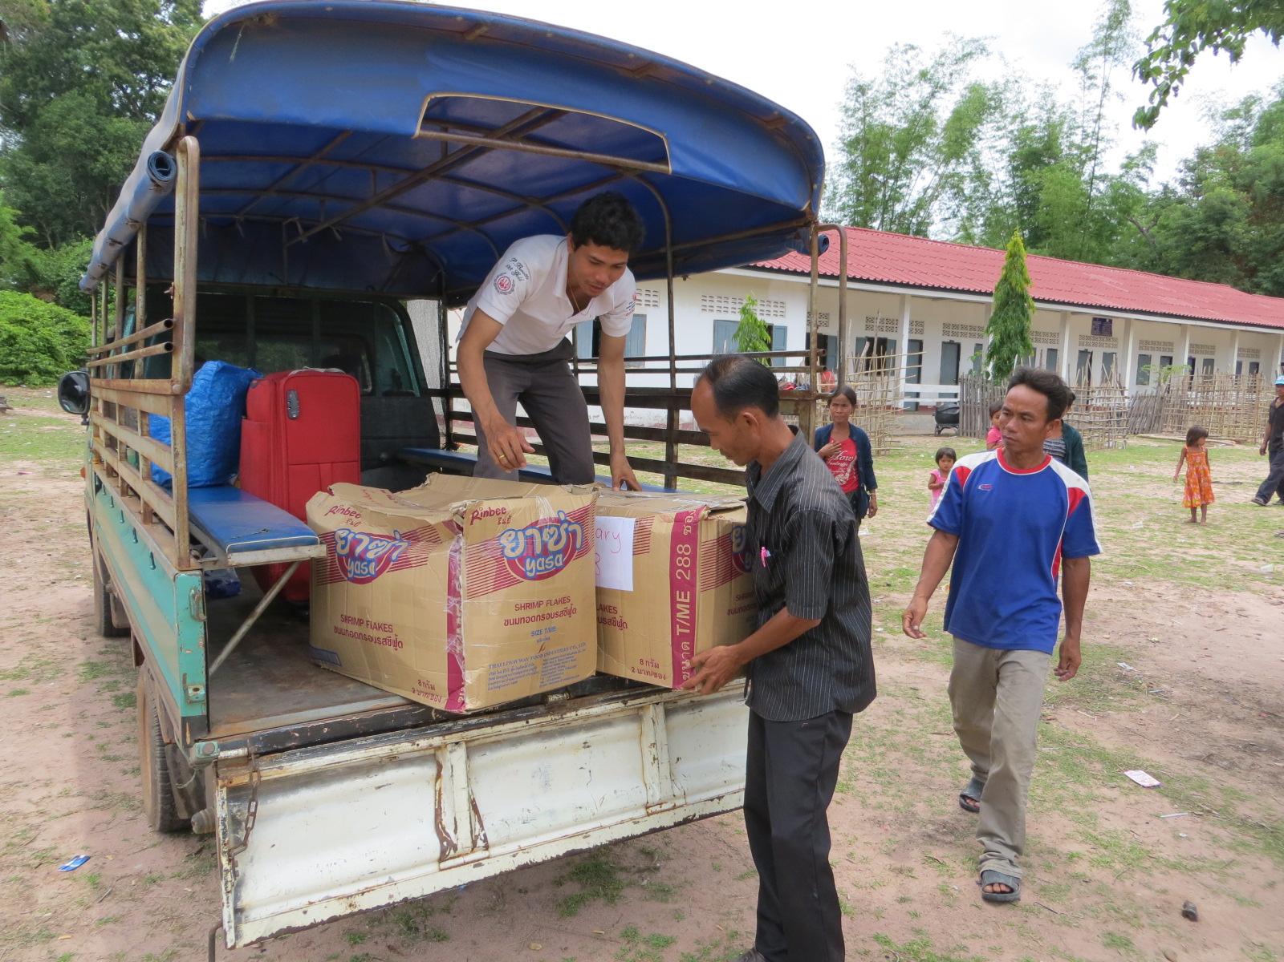
Thank you to MMG for freighting all educational supplies from VTE to SVK for several consecutive years. Here the Lotus team and the father’s are unloading the boxes at the school.

Co-curricula Activity at NIST – Dianne has a wonderful group of supportive students and teachers who work to support Lotus.

Hand made Fair – Organized by I-Cat Gallery in Vientiane, Laos. The Hand Made Craft fair was held in November 2014. Stall holders donated money to Lotus. A total of $700 was raised, greatly appreciated. Thanks Catherine.

Presentations - Helen Keogh presented on three occasions to raise awareness – Wangaratta High School Yr 9 students, Yr 5 students at Vientiane International School and Yr 11 students Vientiane International School.

Donated Clothing – was distributed at the school in May 2015. This clothing had been collected in Bangkok and was greatly appreciated by the girls and their parents.

OVERVIEW of the main program:
The Lotus Educational Fund committee members and supporters, that were available, traveled to Savannakhet, Lao PDR in May 2015 to distribute uniforms, shoes, textbooks, stationary and back packs to the 78 girls currently in the program. Each girl received their individualized pack with a uniform that had been made by the seamstress to their specific measurements.

The committee members meet with the Principal of the various schools. Using a translator discussions were held about the registration fees and the cost of building maintenance. The Lotus Educational Fund pay the registration fee for the 78 girls attending school within the program.

For the academic year 2014 -2015 Lotus has 38 girls in Grade 7 and 40 Girls in Grade 2.
The Village Head originally selected these girls due to their low socio-economic background. One girl per family, from the Champhone district, 35km out of Savannakhet. The consent form had been prepared in Lao, read to the parents and explained prior to them giving consent for their daughter to participate in the program. These girls would otherwise be supporting their families in the rice paddies and by performing household chores. The girls are not required to financially repay Lotus Educational Fund.

Lotus Educational Fund has 38 girls from the Champhone district attending the Nong Kalong Secondary School in Year 7.

For Primary School, all 40 of these Primary girls are in Year 2:

Nong Kalong | Kham Kan | Nonnadie
14 girls | 14 girls | 12 girls

The 1st of September 2014 was the start of the academic year, and early June 2015 is the end of the academic year.

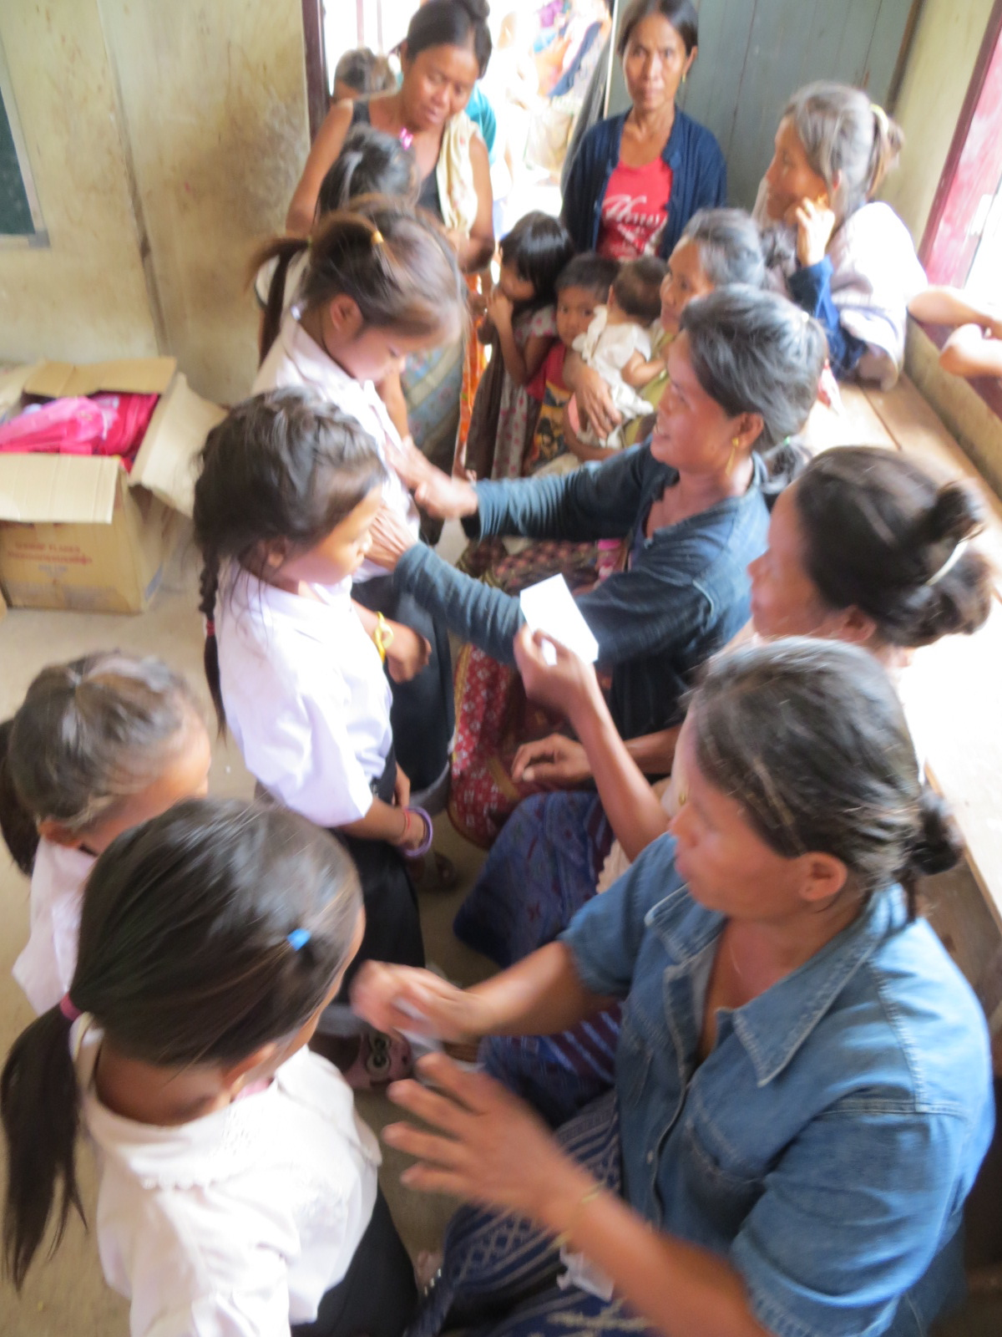
As the partnership between Lotus and the parents continues to strengthen and develop the parents are feeling more empowered. On 16th May 2015 the parents helped by placing name tags on each of the 40 Year 2 girls. We are ready to distribute the educational supplies and uniforms.

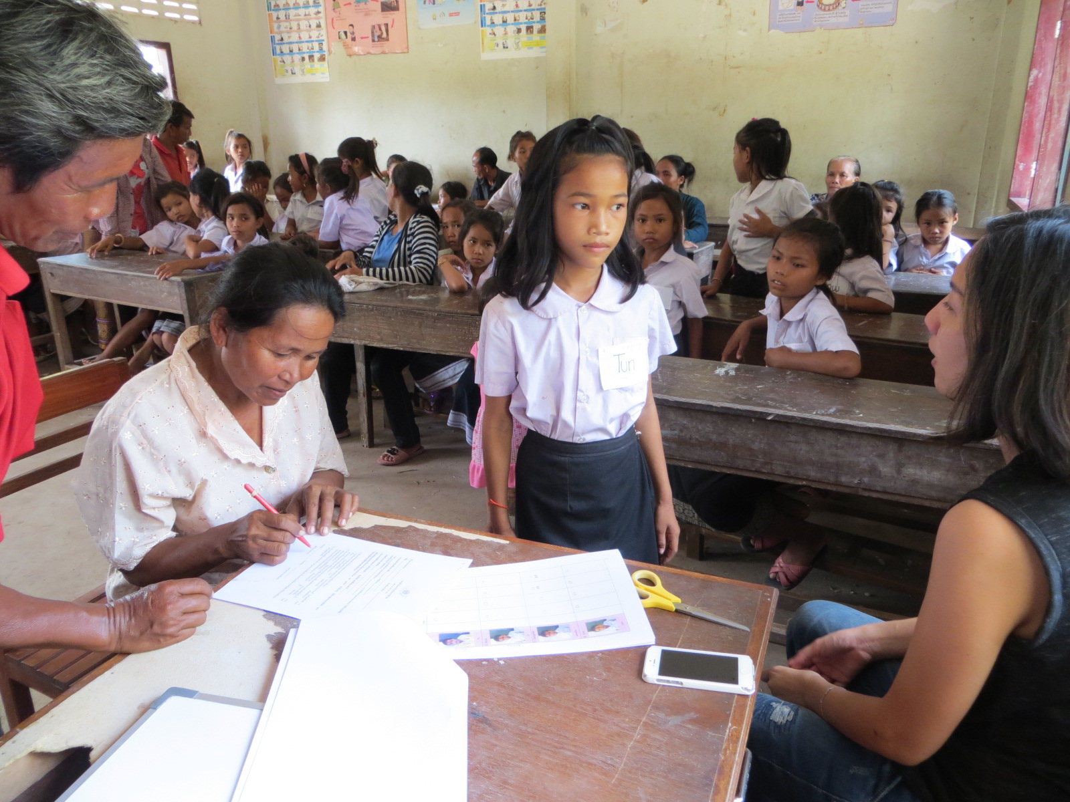
In May 2015 the male teacher is helping Tun’s mother complete the registration form so that Tun can continue to receive Lotus support for Year 3 starting in Sept 2015.

THANK YOU
The Lotus Educational Fund would like to thank all our donors and sponsors for their continued support, ongoing generosity and belief in our vision and mission. Without this support the programs being implement would not be possible. Your support means so much to all the girls involved in the Lotus program, their parents and us.

Educating a girl provides benefits for her, her family and for the life of her children. An educated girl will:
- Tend to get married later and have fewer children.
- Raise healthier, better fed and better educated children.
- Be more productive at home and better paid in the work place.
- Be better able to protect herself against HIV/AIDS.

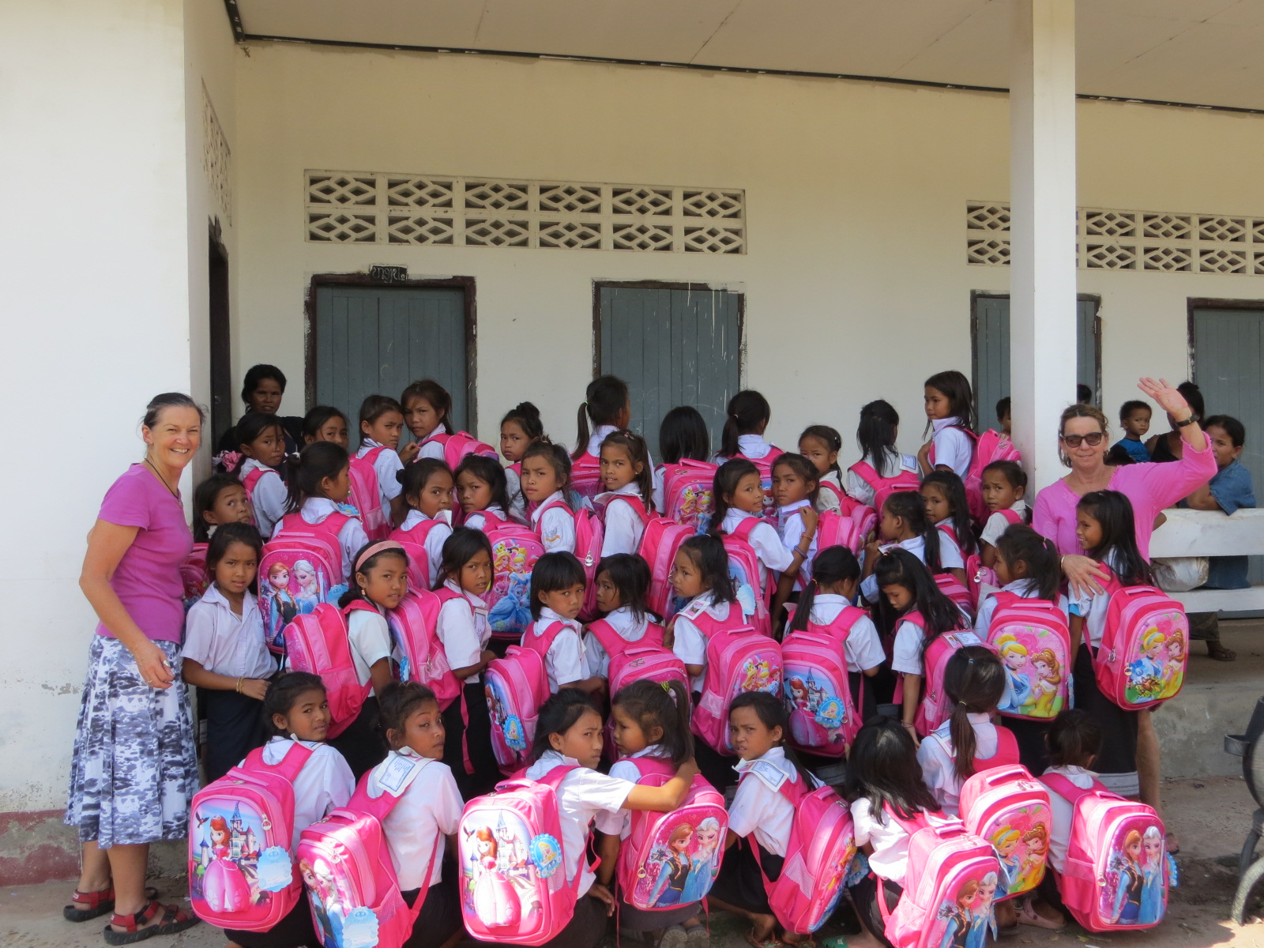
In May 2015 Helen Keogh (left) and Dianne Gamage (right) with the 40 Year 2 Lotus girls just after they have received their new back pack full of educational supplies for Year 3 that will start 1st September 2015.

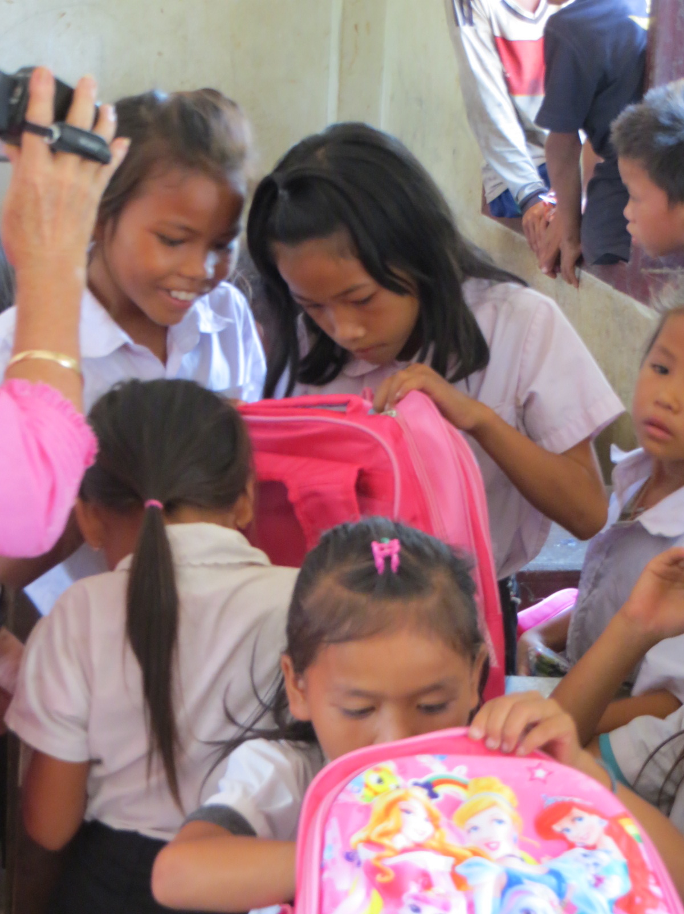
Thank you to all our sponsors, supporters and donors.

The Year 2 girls were so excited to see they had received a skipping rope in their school bags and crayons.

Programs to Implement in 2015-2016
- Hand up Model – to strengthen the partnership parents will be requested to pay a small fee for their child to continue in the program. Secondary girls will be 20,000 kip ($2.50) and Primary girls will be 15,000 kip ($2)

- Women’s Wellbeing workshop Feb 2016 for Lotus Secondary girls.

- Establish a relationship with World Vision in Savannakhet.

- Hand washing / Hand hygiene lessons.
- Mosquito nets – to help prevent dengue fever.
- Meet with Village Head to determine their needs for the schools.
- Logistical Officer contract – Ms Da
- Website updates
- PayPal Business account linked to Lotus website.
- Sponsor updates and newsletters
- Sponsorship
- Monitor exam results of Secondary girls in January 2016 to give a possible indication of how they will perform in final exams in May 2016.
- May 2016 measure each girl for her new uniform.
- May 2016 update Photograph of each girl for file.
- Distribute uniforms and educational supplies May 2016
- Dianne’s co-curricula activity at NIST

Future Programs
- Scholarships for University
- Individual sponsorship for some girls to continue their studies.
- A video of the Women’s Wellness Feb 2016 Workshop.
- A flip chart, for the Secondary teacher to use, to remind all students about safe migration and human trafficking.
- Clean drinking water.
- Soap supplies.

Thank you for your continued support to provide educational resources to girls who love going to school.

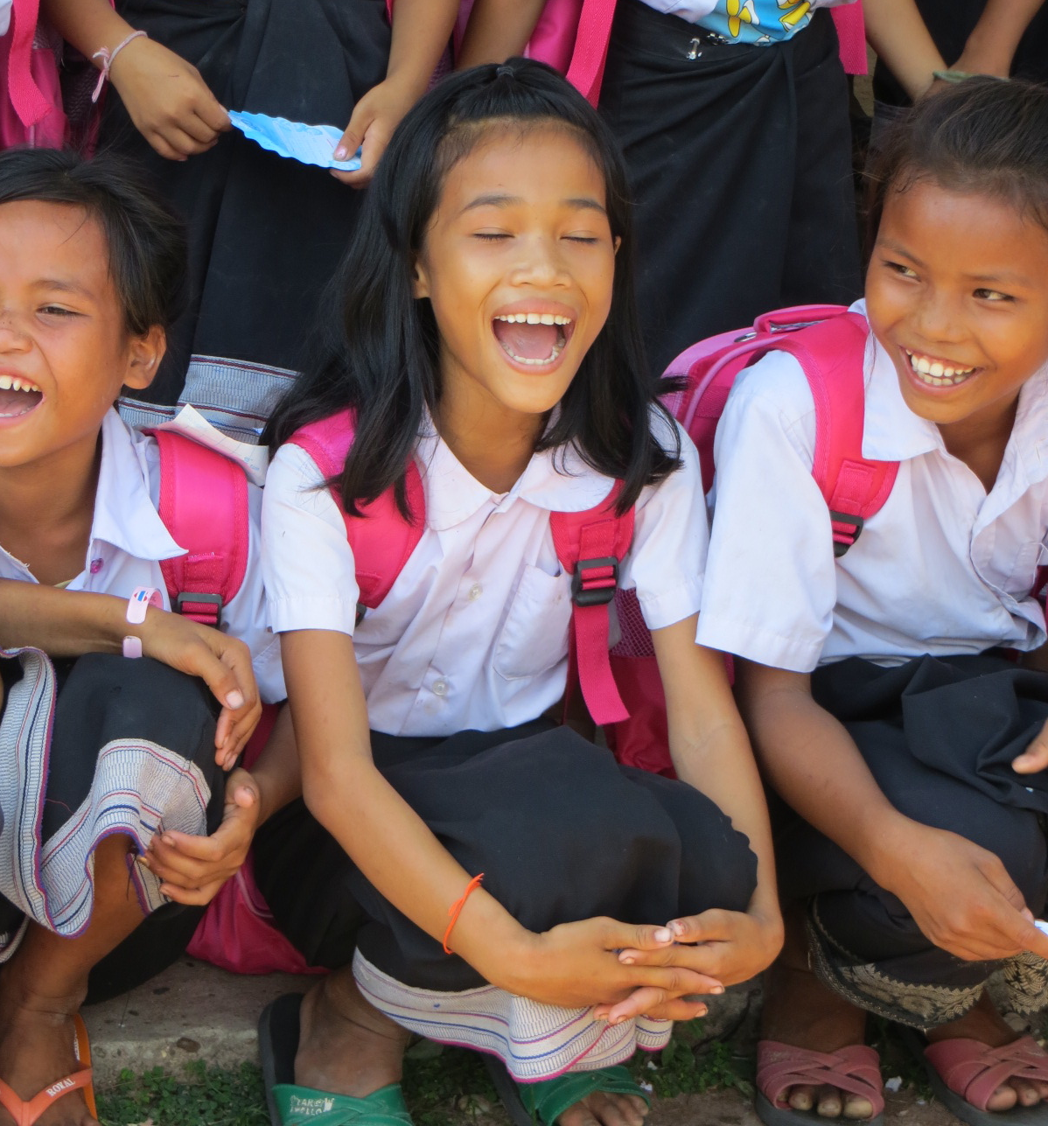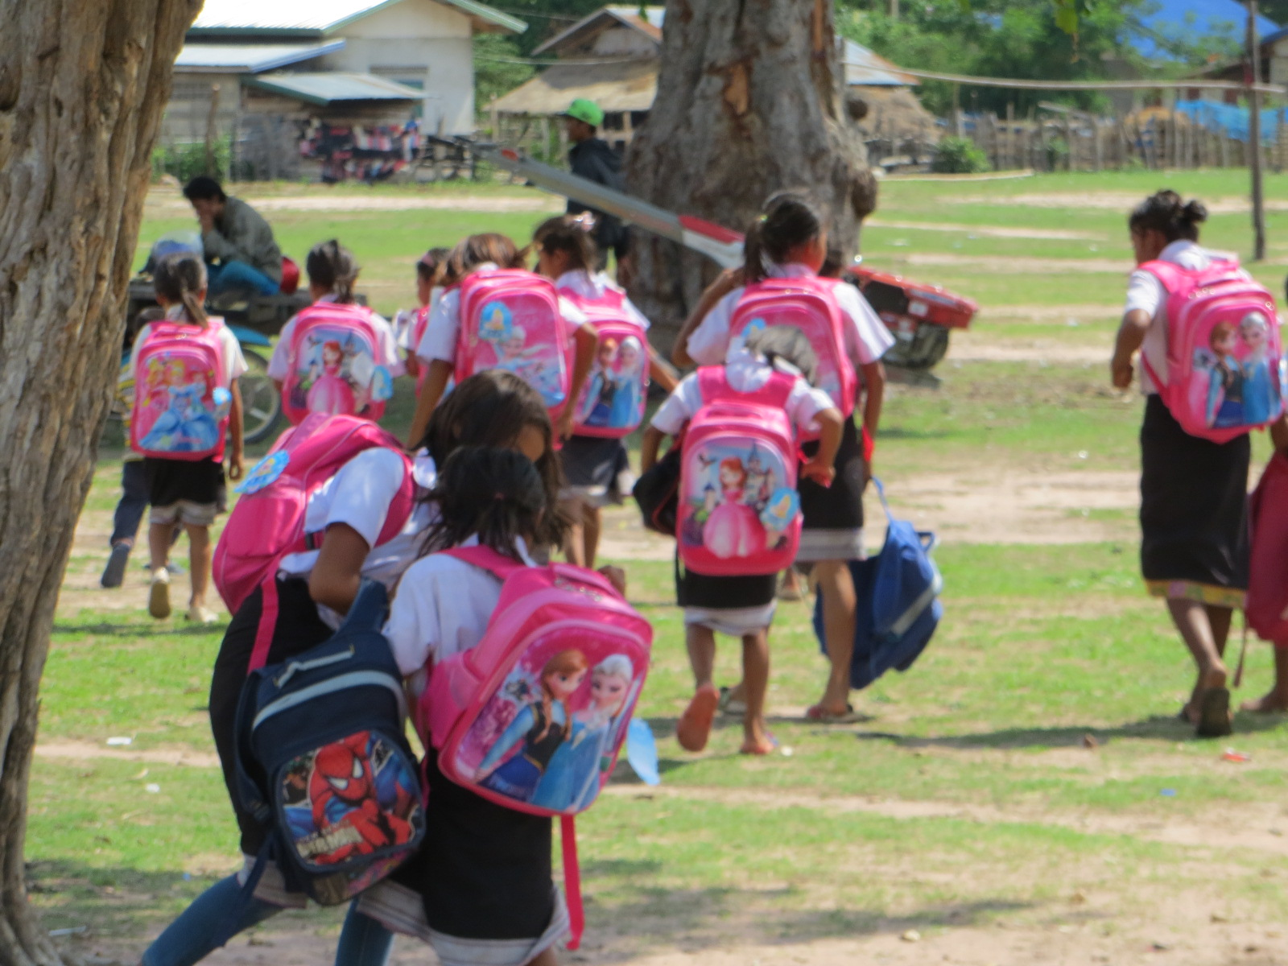

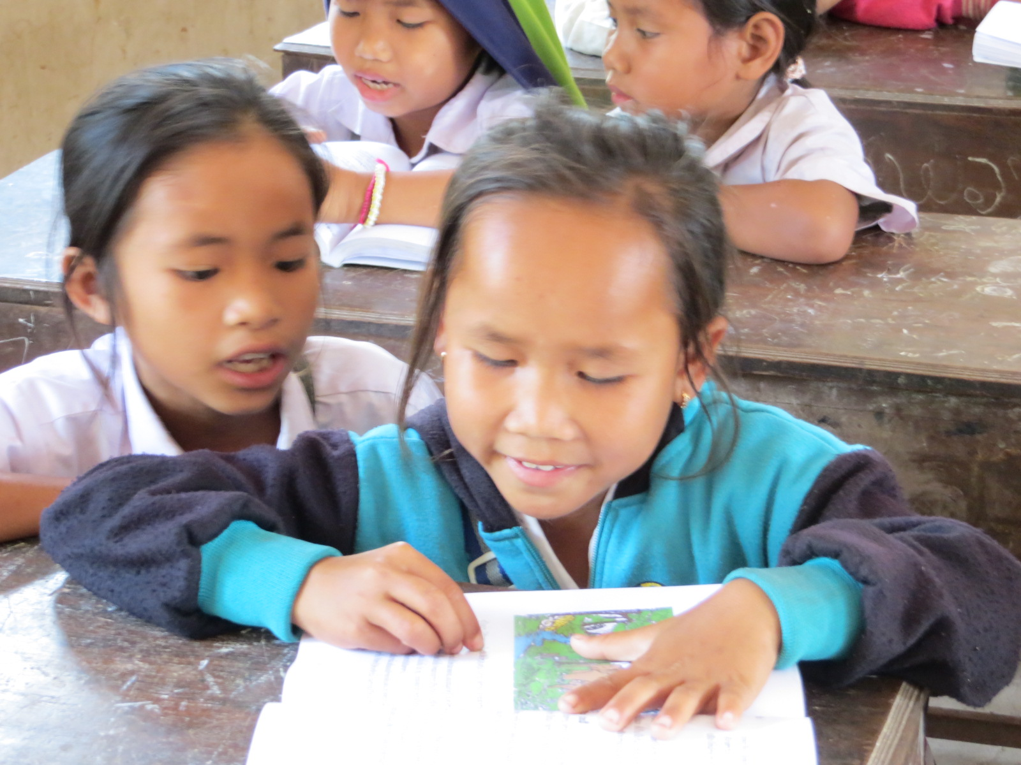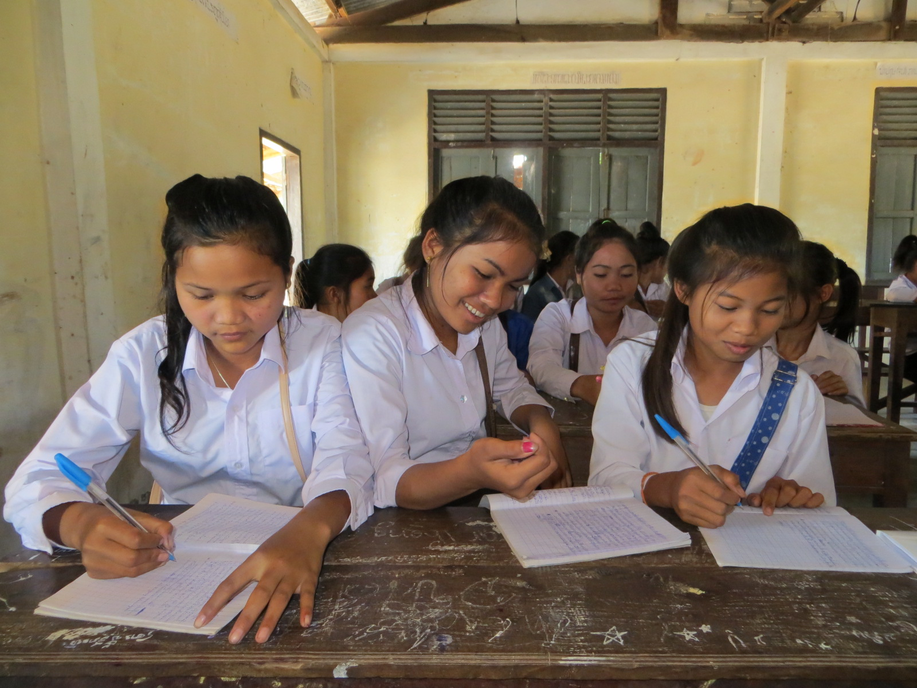

We hope you will continue to support the Lotus Educational Fund in 2016-2017 and beyond!!

http://lotuseducationalfund.com

